**Assignment #11**

**Due 04/20/2021**

1. (**10 points**) Draw time sequence diagram showing TCP segment exchanges and TCP state changes in a simultaneous opening of a TCP connection between two applications.

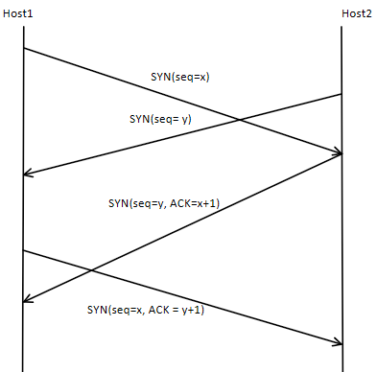

1. (**10 points**) Draw time sequence diagram showing TCP segment exchanges and TCP state changes in a simultaneous closing of a TCP connection between two applications.

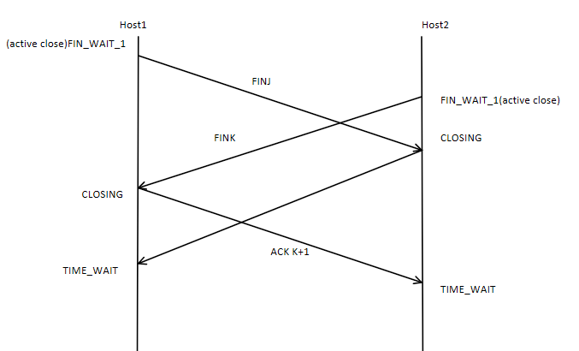

1. (**10 points**) Tabulate transmission delay to send data using entire TCP sequence space onto a link with following speeds:

a) 1 Kbps

* 1. 1 Mbps
  2. 1 Gbps
  3. 100 Gbps
  4. 1 Tbps



1. (**10 points**)
   1. How will you decide if a server you have to create should be TCP-based or UDP-based?
      1. It depends on where your priority lies, If you are focused on reliability then TCP is the way and if you are focused on speed and efficiency then UDP is the way.
   2. How will you tell what is encapsulated in an IP packet?
      1. You can use the protocol field value and refer to the assigned internet protocol numbers documentation
   3. What is the significance of an application doing close on a socket?
      1. It prevents leaked data and also stops other connections from being opened
   4. What is the significance of a value in the Window field of an incoming TCP segment?
      1. It shows the number of bytes that the receiver is going to admit
   5. What is the maximum number of TCP-based and UDP-based applications that can be supported on a system?
      1. Theoretically a system can support up to 65,535 TCP-based and UDP-based applications by in reality it depends on the system itself.